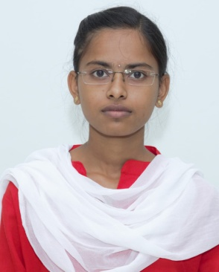**SANGA SAI THANUJA**

Mobile No: +91 9494319196

Email ID:ssaithanuja2613@gmail.com

LinkedIn: https://www.linkedin.com/in/sai-thanuja-sanga-b375b829a

**CAREER OBJECTIVE**

* To secure a challenging and responsible position in a reputable organization where I can apply my knowledge and skills to contribute to the success of company.
* Hoping for a place where I could improve more and more skills.

**TECHNICAL SKILLS**

* Programming languages : C, Basics of Python, Java, HTML, CSS, Basics of JavaScript.
* Office Applications : MS word, Power Point, Excel.

**PERSONALITY TRAITS**

* Able to learn new technologies.
* Can survive in any type of environment.
* Dedication towards the work.

**EDUCATIONAL QAULIFICATION**

* **B.Tech:**
* Stream: ECE
* Percentage Obtained: 76.96%
* **12th:**
* Stream- MPC
* Percentage Obtained- 92.9%
* **10th:**
* Stream: General
* Percentage Obtained- 92.15%

**INTERNSHIP:**

**Title:** Full stack Web Development.

**Duration:** May 2024-July 2024.

**Project Parameters:** HTML, CSS, JavaScript**.**

**CERTIFICATIONS ACHIEVED**

* Participation certificate in Python Programming.
* Certified as an IEEE member.
* Participation Certificate in A State Level Symposium.
* NPTEL Certification in “Programming in Java”.
* Full Stack Web Development.

**PROJECT**

**TITLE** : To-Do List.

**TECHNOLOGY** : Visual Studio.

**DESCRIPTION** : The To-Do List is a simple web application that allows users to add new tasks, and each task is displayed in a list format. Users can remove tasks with a click of a button. The app uses HTML for structure, CSS for styling.

**STRENGTHS**

* Communication skills
* Problem solving skills
* Dedication

**HOBBIES**

* Playing shuttle.
* Watching movies.